Assignment-5

Assignment 5: Begin a transaction, perform a series of INSERTs into 'orders', setting a SAVEPOINT after each, rollback to the second SAVEPOINT, and COMMIT the overall transaction.

Orders Table:
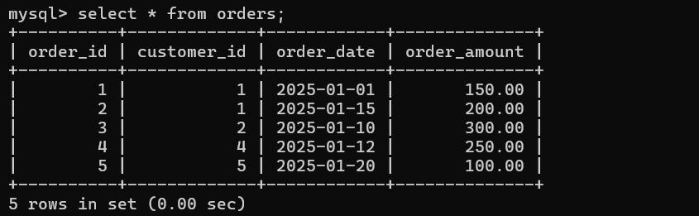

Starting The Transaction By Inserting and making SavePoints:
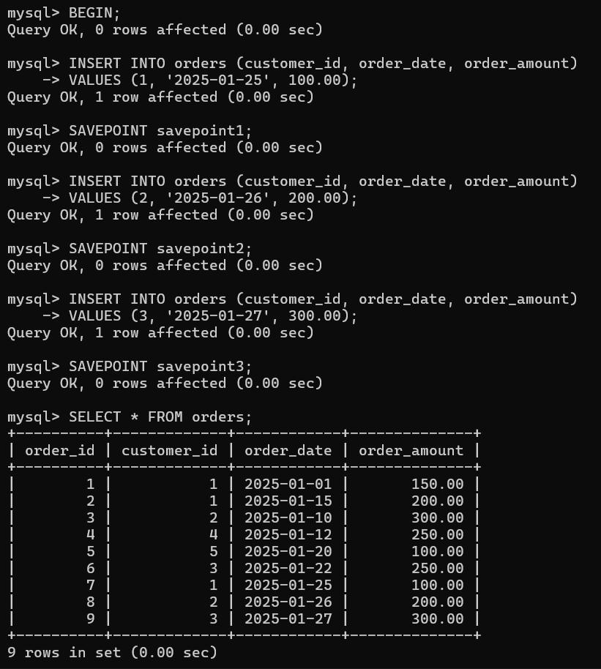

- We have 9 records after creating the savepoints.

ROLLING BACK to Savepoint2:
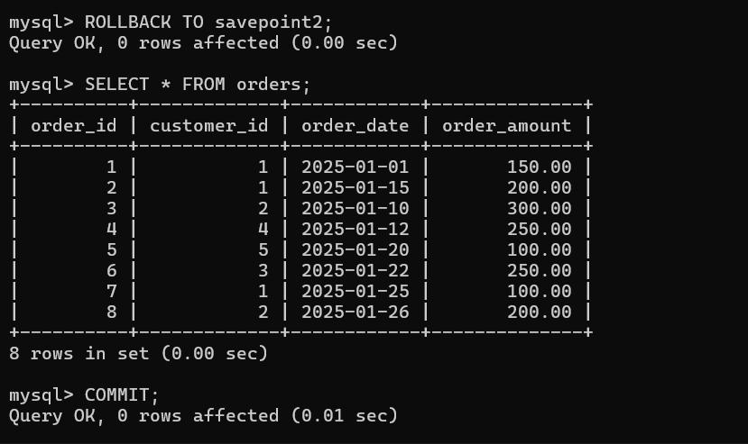

- After Rolled back to savepoint2, it removes that insert or it was roll back the savepoint2

- Then we got 8 records only.

After Commit the orders table:
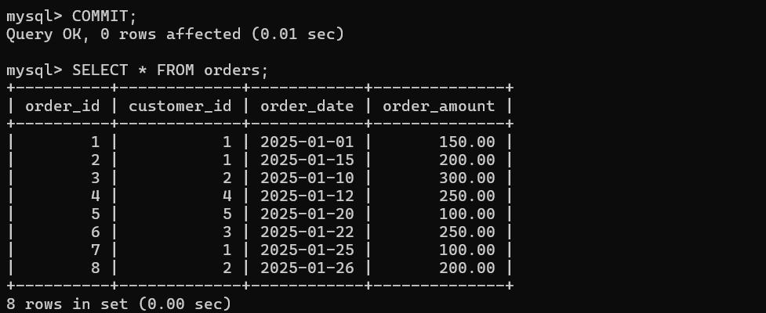

21958_lokesh

